Research title – Template for Authors preparing manuscripts for ICERS conference
1st Author name and surname¹,*, 2nd Author name and surname², 3rd Author name and surname³, etc.
¹ Department name for 1st author, Institution/Company name, City, Country, first.author@mail.com
² Department name, Institution/Company name, City, Country, second.author @mail.com
³ Department name, Institution/Company name, City, Country, third.author @mail.com
* corresponding author
Abstract: Provide a concise summary of the main elements of the study, including its purpose, methods, results and conclusions. This summary should be clear, concise, informative, and provide readers with a preview of the content and significance of the work. The abstract typically includes a brief statement of the research problem or objective, a description of the methods used to address it, a summary of the major results or findings, and a conclusion highlighting the implications or contributions of the study to the field. The summary should be written in such a way that it is accessible to readers of different disciplines and contains enough detail to convey the essence of the study without unnecessary jargon or technical language. Overall, the abstract serves as a concise presentation of the work, allowing the reader to quickly assess its relevance and decide whether to read the full text. The recommended length of the abstract is up to 200 words.
Keywords: Manuscripts; Proceedings; ICERS conference; up to 5 keywords.

Introduction
Provide background information on the topic under study, highlight the importance or relevance of the research, formulate the specific research questions or objectives, and outline the structure or organization of the paper. This section serves to place the study in the context of the existing literature, explain the rationale for the study, and guide the reader through the subsequent sections of the article. In addition, authors may also briefly mention the methods used in the study to give readers an insight into the research approach.

Materials and methods
Provide a clear and detailed description of the experimental procedures and techniques used in the study. This includes information about the materials, equipment, and instruments used, as well as the experimental design, methods of data collection, and statistical analysis performed. Authors should also include any controls or standards used to ensure the validity and reproducibility of the results. In addition, ethical considerations, such as institutional review board approval for studies involving human or animal subjects, should be documented in this section. Overall, the Material and Methods section serves to create transparency and allows other researchers to replicate and validate the results of the study.
Example of bullet style:
- 1st February 2026 – Abstract submission
- 1st April 2026 – Full paper submission (up to 8 pages)
- 1st May 2026 – Registration
- 1st - 3rd July 2026 – ICERS Conference (Zagreb, Croatia)

Reference style and citations
All citations in the text should refer to:
- Single author: the author's name (without initials, unless there is ambiguity) and the year of publication (Woodcock 1987);
- Two authors: both authors' names and the year of publication (Zhu and Woodcock 2014);
- Three or more authors: first author's name followed by "et al." and the year of publication (Roy et al. 2021).
Citations may be made directly (or parenthetically). Groups of references should be listed first alphabetically, then chronologically.

Tables, figures and equations
Example of table caption style and table contents style (Table 1).
Table 1. Sentinel 2 bands in 10-m spatial resolution.
Band | Resolution | Central Wavelength | Description
B2 | 10 m | 490 nm | Blue
B3 | 10 m | 560 nm | Green
B4 | 10 m | 665 nm | Red
B8 | 10 m | 842 nm | Visible and Near Infrared (VNIR)
Example of figure style and caption (Figure 1).
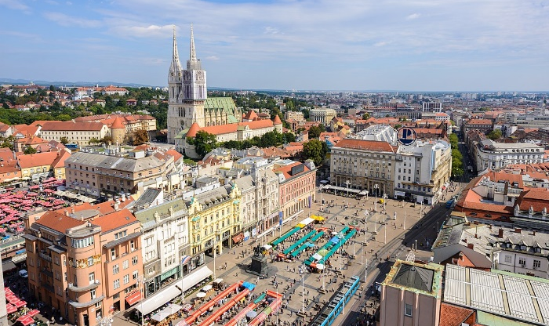
Figure 1. Zagreb, Capital of Croatia.
Example of equation style. The Normalized Difference Vegetation Index (NDVI) calculated on the basis of the Sentinel 2 bands is shown in equation (1).
(1)

Results
Provide and present the results of their study in a clear, concise and organized manner. This includes presenting the findings of experiments, analyzes or observations without interpretation or speculation. Authors should provide data in the form of tables, figures, or text, depending on the nature of the results. It is important to adhere to the principles of scientific integrity by accurately representing the data and avoiding selective reporting. Authors should also use appropriate statistical methods to analyze the data and report the results of these analyzes. Overall, the results section should objectively present the main findings of the study so that readers can evaluate the evidence and draw their own conclusions.

Discussion
Interpret and contextualize the results presented in the Results section. This includes explaining the significance of the findings in relation to the aims of the study and the wider scientific context. Authors should compare their results with previous research, discussing similarities, differences and possible explanations for discrepancies. It is important to critically evaluate the strengths and limitations of the study and address possible sources of bias or confounding factors. Authors should also propose hypotheses or mechanisms to explain the observed results and suggest avenues for future research. Overall, the Discussion section offers authors the opportunity to summarize their findings, draw conclusions, and contribute to the advancement of knowledge in the field.

Conclusions
Summarize the key findings of the study, reiterate their significance in the context of the research objectives, and discuss their implications for the broader field. This section usually highlights the major contributions of the study and suggests possible applications or avenues for future research. It serves as a final synthesis of the study findings, concluding the paper and emphasizing its importance to the scientific community.
Acknowledgments: In this section, authors have the opportunity to express their gratitude for any additional support or funding. This may be administrative support, technical advice or donations in kind, such as materials used for experiments. Some examples: “This research received no external funding” or “This research was funded by NAME OF FUNDER, grant number XXX”." This section is optional.

References
Example reference to a journal publication:
Lee, C., Bethel, J.S., 2004. Extraction, modelling, and use of linear features for restitution of airborne hyperspectral imagery. ISPRS Journal of Photogrammetry and Remote Sensing 58 (5-6), 289-300.
Example reference to a book:
Lillesand, T.M., Kiefer, R.W., 2000. Remote Sensing and Image Interpretation, fourth ed. John Wiley & Sons Inc., New York.
Example reference to a chapter in an edited book:
Förstner, W., Wrobel, B., 2004. Mathematical concepts in photogrammetry. In: McGlone, J.C., Mikhail, E.M., Bethel, J., Mullen, R. (Eds.), Manual of Photogrammetry, fifth ed. American Society of Photogrammetry and Remote Sensing, Bethesda, MA, pp. 15-180.
Example reference to a conference publication:
Grodecki, J., 2001. Ikonos stereo feature extraction - RPC approach. Proc. ASPRS Annual Conference, St. Louis, 23-27 April. 7 p. (on CDROM).
Shenkelaars, V.F., Egenhofer, M.J., 1997. Exploratory access to digital geographic libraries. In: editors (Eds.), Proc. 13th International Symposium on Computer Assisted Cartography (Autocarto 13), ACSM/ASPRS, Seattle, WA, 5-10 April, pp. 297-306.
Example reference to a website:
Streetmapper, 2006. StreetMapper Mobile Mapping Using Lidar, http://www.streetmapper.net. (Accessed 23 November, 2006)
For creation and preparation of references and citations, we recommend the use of reference management software such as Mendeley and the ISPRS Journal of Photogrammetry and Remote Sensing citation style.

The recommended length of the full paper is up to 8 pages, including references.

